**Project Proposal**

**SRA 311**

**Michele Calderon, Logan Clay, Nicholas Coombes,**

**Jordan Fisher, Charles Kindt, Constance McConnon**

**Project Link**

Github Link:

<https://github.com/ncoombes95/SRA-311-Project>

Project Manager:

Nicholas Coombes, [Nfc5164@psu.edu](mailto:Nfc5164@psu.edu), 484-333-2123

**Executive Summary:**

The United Parcel Service, or UPS, is the global leader in package shipping and delivery and supply chain management. In 2019, UPS delivered 5.5 billion packages and documents globally. As in-store retail purchases by consumers decrease and remote work for businesses increase, the importance of functionality in daily operations will be vitally important to UPS. Our risk analysis will highlight the unique challenges associated with UPS in its delivery and supply chain management for businesses and the general public. The SHEL Model below outlines the relationships of major assets.

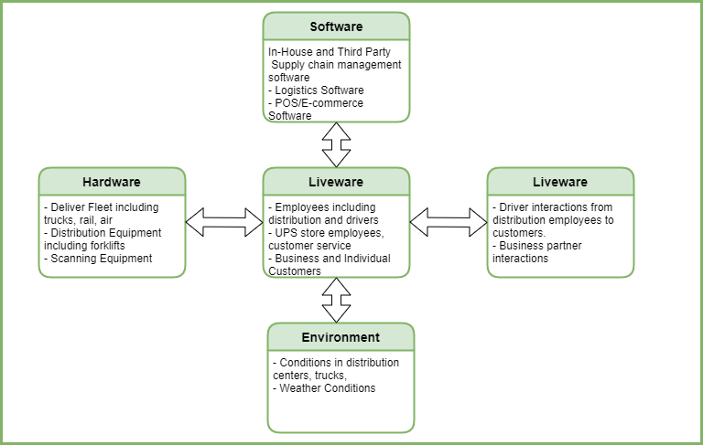

For our risk analysis, we will be using the National Institute of Standards and Technology (NIST) Guide for Conducting Risk Assessments (Special Publication 800-30). This methodology will allow us to properly organize threats and vulnerabilities through the NIST’s four step process for risk assessment of framing, assessing, responding, and monitoring risks.

By completing this assessment, we will be able to highlight specific areas of focus that are vital to their successful delivery of 2.19 million packages and documents daily, protection of customer information, and the safety of its employees, specifically drivers. While some risks like driver safety may be small in scale and monetary value, the reputation of UPS rests in all business functions working together and on-time for customer satisfaction. With revenue of $74 billion in 2019, UPS should be able to spare no expense to manage any major or minor risk.

**Background Information of the Organization:**

Established in 1907, UPS is a global courier and logistics company with its headquarters in Atlanta, GA. UPS’s CEO Carol Tome presides over 13 members in its Board of Directors which includes AT&T’s CEO John T. Stankey, former Heinz CEO William R. Johnson, and CVS’s CFO Eva Boratto. UPS employs 528,000 employees globally, with more than 1,800 operating facilities and 125,000 cars, vans, etc in its packaging delivery fleet. In addition to its delivery fleet, UPS also has over 500 jets. It provides customer access in over 220 countries and territories through its website ups.com, 5,200 retail stores, approximately 9,200 partnerships with authorized outlets, more than 37,000 UPS Drop Boxes, etc. UPS also offers supply chain management and operates UPS Freight through vehicles and trailers with 200 service centers across the U.S.

Mission of UPS (in terms of multiple success criteria)

* Distribution of packages for business and consumer customers in a safe and timely manner.
* Solutions in shipping for business and consumer customers that is convenient.
* Operation of supply chain management through logistics and distribution for speed of service.
* Innovation in supply chain management, logistics, and business solutions with a focus on data analytics and market insight.

Essential Business Functions

* Information systems for supply chain management and logistics
* Pick-up and delivery of parcels and documents with signatures where required
* Maintenance of fleet including vehicles, trucks, motorcycles, jets, tractor trailers
* Customer satisfaction that packages and documents arrive on time and in good condition
* Operations at warehouses including using heavy machinery
* Research and development of new technology for shipping and receiving

Our assessment will focus on information security, pick-up and delivery, and fleet maintenance.

Information for a request can be generated through multiple outlets. When a request is started a tracking number and shipping label will be created. Once the information is storage in a database on a secure server, it can be accessed by facilities, drivers, and customers. Logistical routes will be created and once the transaction is complete, the server is updated.

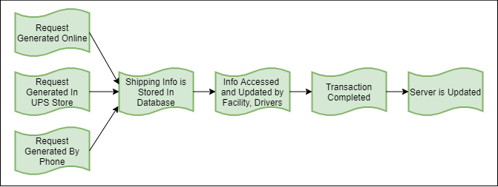

In shipping and delivery, a request is made that generates a tracking number and label. The facility that receives this information will then dispatch a driver for pick-up. The package can then move on to facilities across the world depending on its destination. The receiving facility will then send the package out for delivery. Once the package is delivered the transaction is complete.

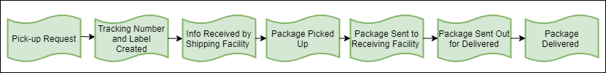

Maintenance of the delivery fleet is vitally important to ensure packages are delivered on time for customer satisfaction. Preventative maintenance could be required depending on amount of use or season. Maintenance could be required if mechanical issues occur. A vehicle would be made unavailable for while it is in for maintenance. Once maintenance is complete, the vehicle would be made available again for pick-ups and deliveries.

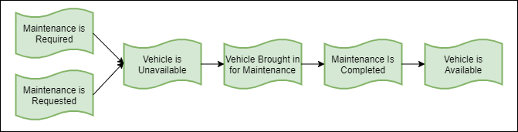

**Stakeholder Analysis:**

|  |  |  |  |  |
| --- | --- | --- | --- | --- |
| **Major Stakeholders** | **Urgency** | **Legitimacy** | **Capacity** | **Importance** |
| **Definitive- CEO, Board Members** | **X** | **X** | **X** | **4** |
| **Dominant- Governments (Domestic and International)** |  | **X** | **X** | **2** |
| **Dangerous- Disgruntled Employees, Hackers, Robbers** | **X** |  | **X** | **3** |
| **Dependent- Customers** | **X** | **X** |  | **3** |

By understanding the stakeholders and their levels of importance, we can see who will be affected most by risks and solutions we will propose. Additionally, we can better assess what specific risks will have the greatest impact on the business functions of UPS with consideration of these stakeholders and who has the power or perceived power to influence. For instance, if we find a high frequency of vehicle maintenance or accidents involving drivers, we will be able to offer solutions to reduce those risks which will decrease lawsuits and the number of affected employees. Mitigating risk of loss of tracking information will impact customer satisfaction. The information provided by this assessment will impact definitive stakeholders in terms of profit.

**Project Scope Statements:**

The three business functions we will focus on are shipping, delivery and fleet maintenance. The reasoning for this is that the project will be focusing on the importance and efficiency of Amazons ability to safely and efficiently deliver packages to its users. Without the function of the three branches of Amazons delivery services up above, Amazons main form of economic sustainability would hinder and potentially grind to a halt, crippling the company. This, in comparison with Amazons other divisions could be deemed as their most important in those regards above. Amazon started small but eventually grew to its current size from selling items online. The only way for this main way of living for Amazon to remain upheld is by its ability to ship its products, deliver them, and keep those delivery trucks/drones/drivers going.

*Assets:*

|  |  |
| --- | --- |
| **Shipping** | |
| Employees | Warehouse Associates |
| Hardware | Computers, Printers |
| Software | Databases, tracking systems |
| Data | Customer records, product records |

|  |  |
| --- | --- |
| **Delivery** | |
| Employees | Delivery Drivers |
| Hardware | Vehicles, scanners |
| Software | Databases, tracking systems, GPS |
| Data | Customer records, product records |

|  |  |
| --- | --- |
| **Fleet Maintenance** | |
| Employees | Mechanics |
| Hardware | Vehicles, tools |
| Software | Maintenance software |
| Data | Service records |

*Possible Security Incidents:*

|  |  |  |
| --- | --- | --- |
| **Shipping** | | |
| **Security Incident** | **Category** | **Covered in Analysis?** |
| Package does not arrive | 1 | Yes |
| Data breach | *2* | Yes |

|  |  |  |
| --- | --- | --- |
| **Delivery** | | |
| **Security Incident** | **Category** | **Covered in Analysis?** |
| Vehicle damage | 2 | Yes |
| Data breach | *2* | Yes |

|  |  |  |
| --- | --- | --- |
| **Fleet Maintenance** | | |
| **Security Incident** | **Category** | **Covered in Analysis?** |
| Damage during repair | 1 | Yes |
| Incorrect Service Records | 2 | Yes |

**Preliminary Risk Analysis:**

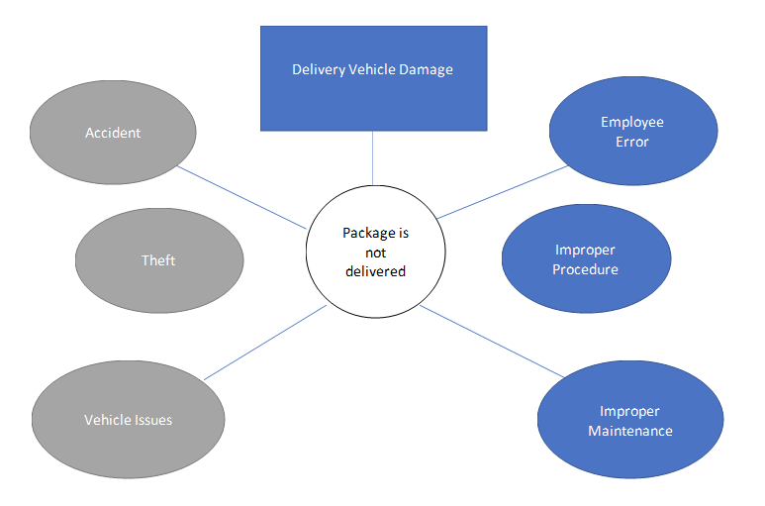

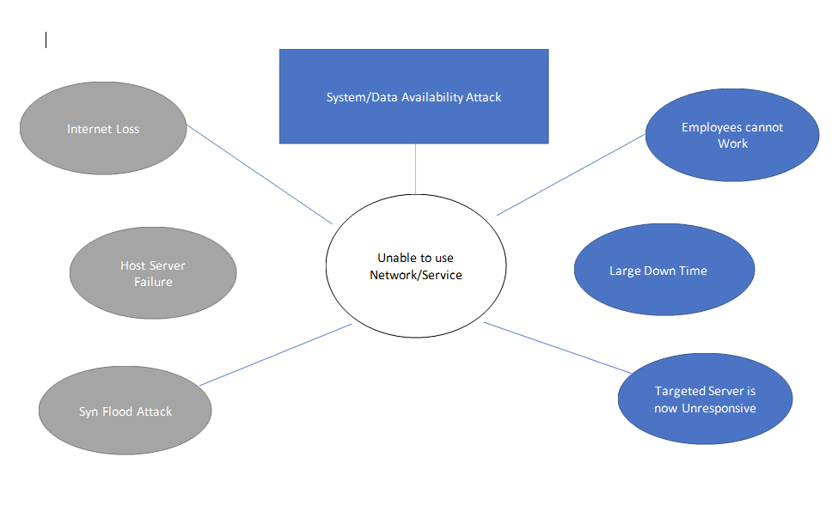

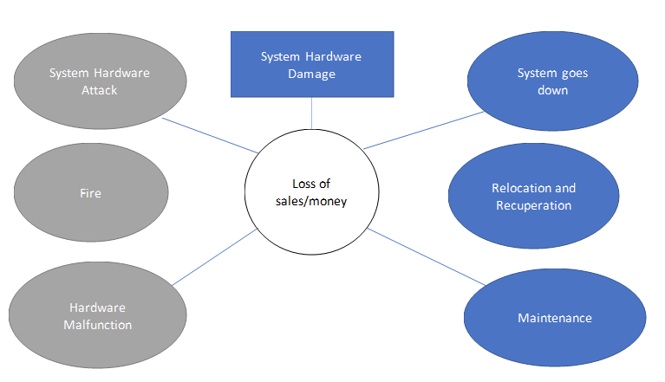

**Data Collection and Analysis:**

To calculate the risks that UPS faces we must first:

*1- Identify potential hazards*

*2- Determine who might be harmed*

*3- Evaluate the risks*

*4-Record findings*

*5- Review/ update findings*

We will use these resources:

<https://www.ups.com/us/en/services/knowledge-center/article.page?kid=cd7197f3&articlesource=longitudes>

<https://marketrealist.com/2016/04/united-parcel-service-company-overview/>

<https://www.automotive-fleet.com/306468/ups-lowered-accident-rate-last-year#:~:text=UPS%20lowered%20the%20frequency%20of,in%20its%20annual%20sustainability%20report.>

[**https://pressroom.ups.com/pressroom/ContentDetailsViewer.page?ConceptType=FactSheets&id=1426321563187-193**](https://pressroom.ups.com/pressroom/ContentDetailsViewer.page?ConceptType=FactSheets&id=1426321563187-193)

**Development Plan:**

1. Complete Project Proposal- 10/9/2020
2. Complete Peer Evaluation- 12/03/2020

* Individually completed by all team members

1. Complete Project Presentation- 12/08/2020 or 12/10/2020
2. Complete Project Paper- 12/14/2020

The team will work together on each of the components of the project. Nick, Jordan and Constance will work on the power point while Michele, Charles and Logan work together on the paper. We will reconvene and share our progress each week to ensure consistency throughout the deliverables. Data and project items can be stored in the GitHub account or Microsoft Teams. Communication will be done through Canvas, Microsoft Teams, or Zoom. A standing Zoom meeting time of 4:30 pm on Thursdays will be in place to discuss major elements of the project.

**References**

*Board of Directors.* (n.d.) UPS Investors. Retrieved from [**http://www.investors.ups.com/governance/board-of-directors**](http://www.investors.ups.com/governance/board-of-directors)

National Institute of Standards and Technology/U.S. Department of Commerce. (2012). *NIST Special Publication 800-30: Guide for Conducting Risk Assessments Revision 1* [PDF]*.* Gaithersburg, MD. Retrieved from <https://nvlpubs.nist.gov/nistpubs/Legacy/SP/nistspecialpublication800-30r1.pdf>

*UPS Fact Sheet.* (n.d.). UPS Pressroom. Retrieved from <https://pressroom.ups.com/pressroom/ContentDetailsViewer.page?ConceptType=FactSheets&id=1426321563187-193>

[**https://www.bls.gov/iag/tgs/iag48-49.htm**](https://www.bls.gov/iag/tgs/iag48-49.htm)

[**https://www.bls.gov/oes/2018/may/oes533033.htm#ind**](https://www.bls.gov/oes/2018/may/oes533033.htm#ind)

[**https://www.bls.gov/iif/oshwc/cfoi/truck-drivers-2018.htm#:~:text=Light%20truck%20or%20delivery%20services%20drivers%20had%20an%20incidence%20rate,was%2034.0%20for%20all%20occupations**](https://www.bls.gov/iif/oshwc/cfoi/truck-drivers-2018.htm#:~:text=Light%20truck%20or%20delivery%20services%20drivers%20had%20an%20incidence%20rate,was%2034.0%20for%20all%20occupations)**.**